Thandai Juice Corner

Parvez Hossain Saurav

# Restaurant Concept

**Restaurant Name & URL**

Thandai Juice Corner

thandai.com

Healthy Organic Juice Delivery Service and daily subscription.

**Food & drink**

*Customization*

* Yummy Health
* Orange Juice
* Lemon Mint
* Rime Mango Juice
* Koromcha Juice
* Blackberry Juice
* Grape Juice
* Pineapple Juice
* Watermelon Juice
* Health Boost
* Jeera Pani
* Olive Juice
* Carrot Juice
* Papaya Juice
* Special
* Greeny Myny
* Desi Beet

**Location**

Rajlaxmi Complex, Sector #3, Uttara, Dhaka

Delivery Radius: Dhaka City

**Main target audience**

* Health conscious
* Juice Lover
* Fitness Geeks
* Teens
* Elderly People

**Cost**

*$ - Affordable*

**Elevator pitch**

*Healthy Yummy organic juice at your door step. Feeling hot in summerdays or need a health boost Thandai is here to meet your everyday juicy need.*

# Strategy

## Target Audience

The website/app will focus on the following target audiences:

**Roles** (groups of people with similar goals)

* *Health Worker*
* *Juice lover looking for organic juice*
* *Health concious Adult citizens*
* *Young Fitness Geeks.*
* *Young youthful students*

**Demographics**

* **Gender** - Male and Female
* **Education** -Moderate to High
* **Occupations** - Health Workers, Students, Fitness Fanatic
* **Age** - 18-65
* **Location** - Dhaka ( Mainly Dhanmondi, Azimpur, Zhigatola, Mohammadpur, and Shamoly.)

**Psychographics** (personality, values, attitudes, interests, lifestyles)

*Think of at least 5 details among the categories below.*

* **Personality & Attitudes:** 
  + Health Concious
  + Youthful
  + Fitness Fanatic
* **Values:** 
  + Religious ( No Alcohol)
  + Health Safty
* **Lifestyles:**
  + Routine Lifestyle
  + Active
  + Family
  + Atheletic & Energetic

# 

# Strategy

## 1User Personas (optional)

**Arfan Khan (17) – Fitness Guy**

* 17 year old college student
* Play football in college
* Fitness fanatic
* Don’t drink alcohol



**Selin Akhter (28) – Health Worker**

* Work at Anisa Health Clinic
* Married for 3 years
* Mother of one child
* Serious about freash and nutreint food for her family.



**Junayed Hossen (48) – Director of NSLA Corp.**

* 48 year old busy director
* Married for 15 years
* Father of 2 children
* Has many health issue
* Have follow a strict healthy routine

# 

# Strategy

## User Needs

The website needs to enable the user to:

* Find out if the delivery is available in the area
* Order Juice online
* Activate Subscription of package for daily Organic Juice delivery
* View and choose from different type of juice
* Maintain different subscriptions
* Find out if the juice corner is open

## Client Needs

The website needs to enable the client to:

* Deliver juice online
* Providing daily subscription base service
* Provide a system for order customization
* Communicate reliabily
* Advertising different type of juice availibility

# Outline of Scope

## Content Requirements

Content (text, images, video) that the user will need.   
*“The user will be looking for…”*

* Location
* Openning Time
* Drink Options
* Drink Images
* Drink Prices
* Drink Ingredient
* About Us
* Subscription Packages
* Subscription Process
* Contact
* FAQ
* Customer Review

## 

## Functionality Requirements

Systems that will allow the user accomplish tasks.

*“The user will be able to…”*

* Place Custom Order
* Check Availability
* Local Payment methods
* Track Order
* Create Account
* Log in
* Juice Delivery Subscription
  + Delivery Interval
  + Delivery Selection
  + Bill Calculator
* Live Chat Support
* Large Order Booking

# Artboard – 2Sitemap

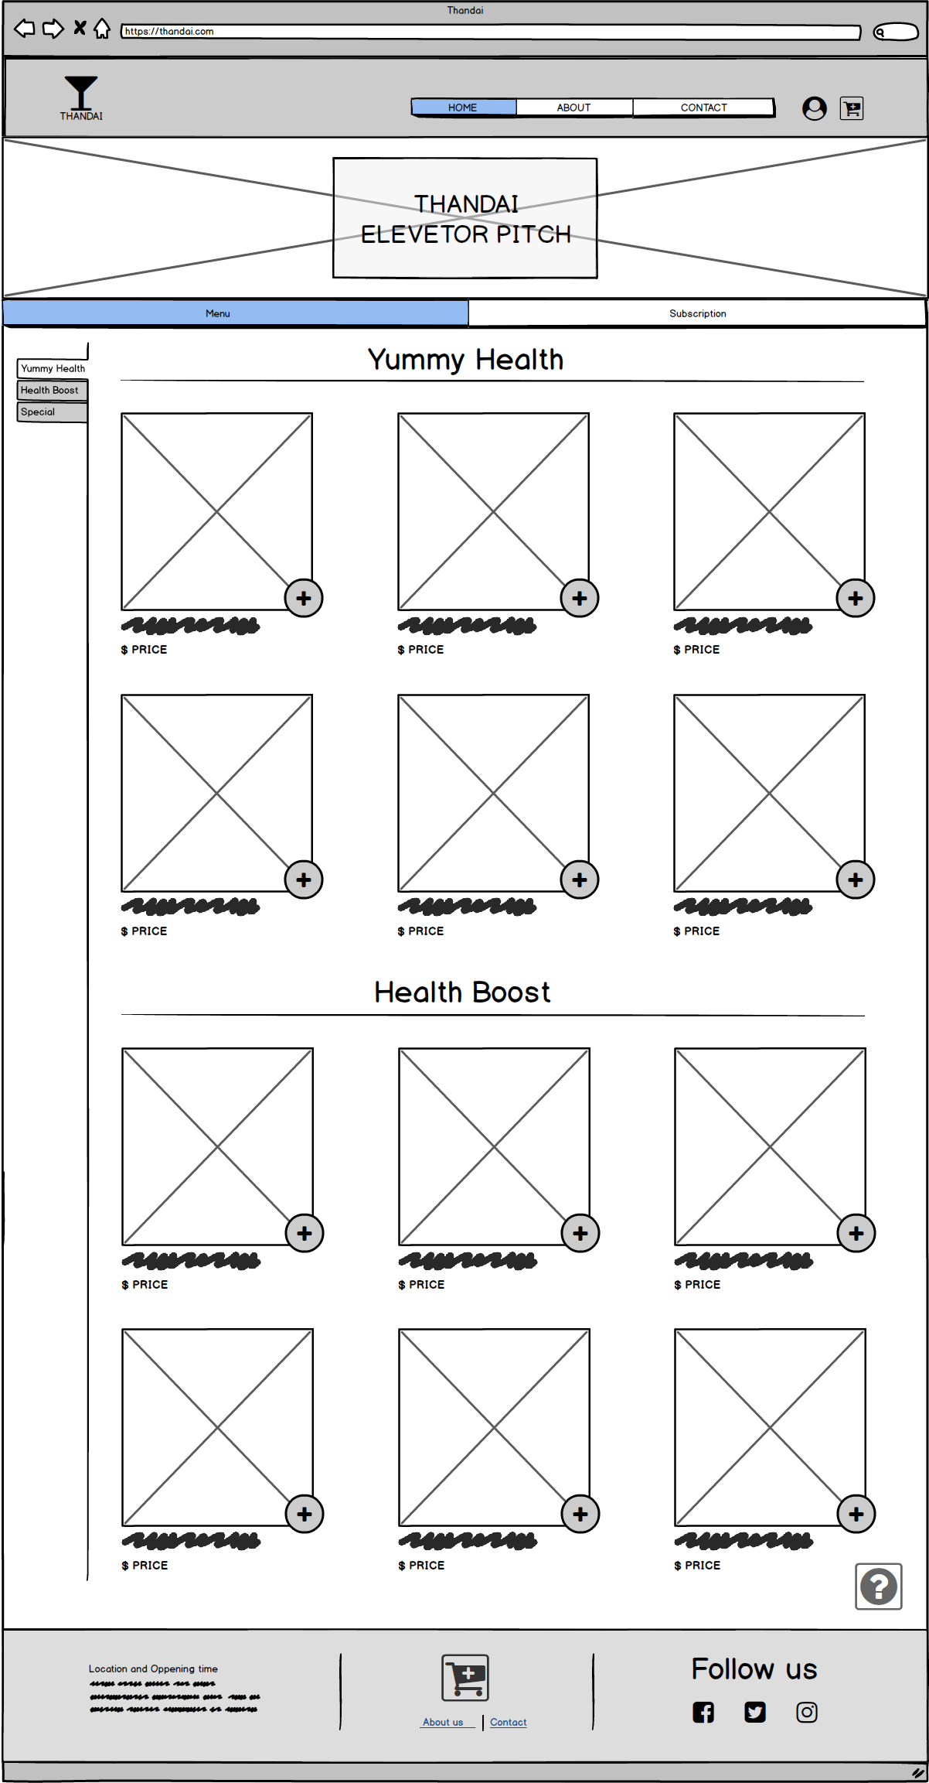Desktop Home

Custom Menu

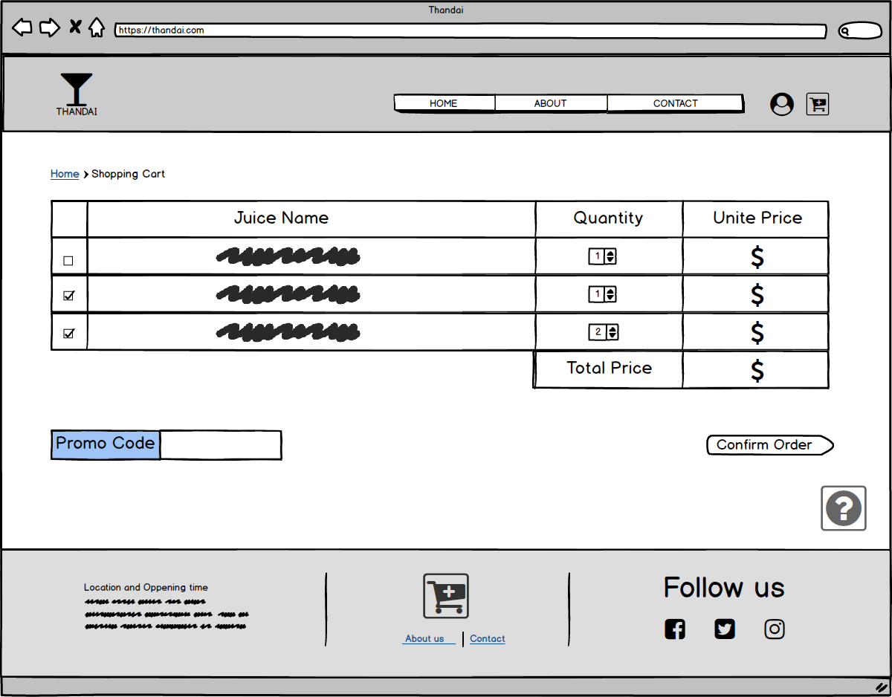Shopping Cart

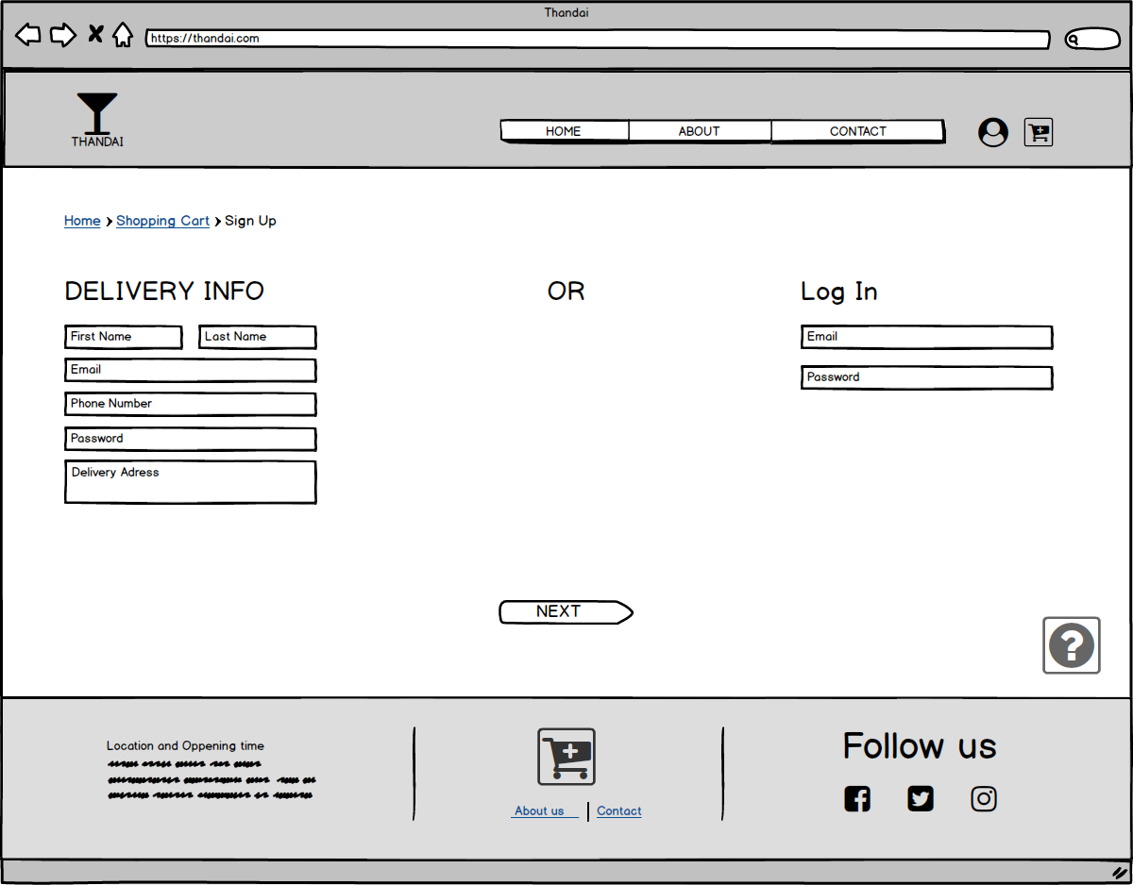Sign Up

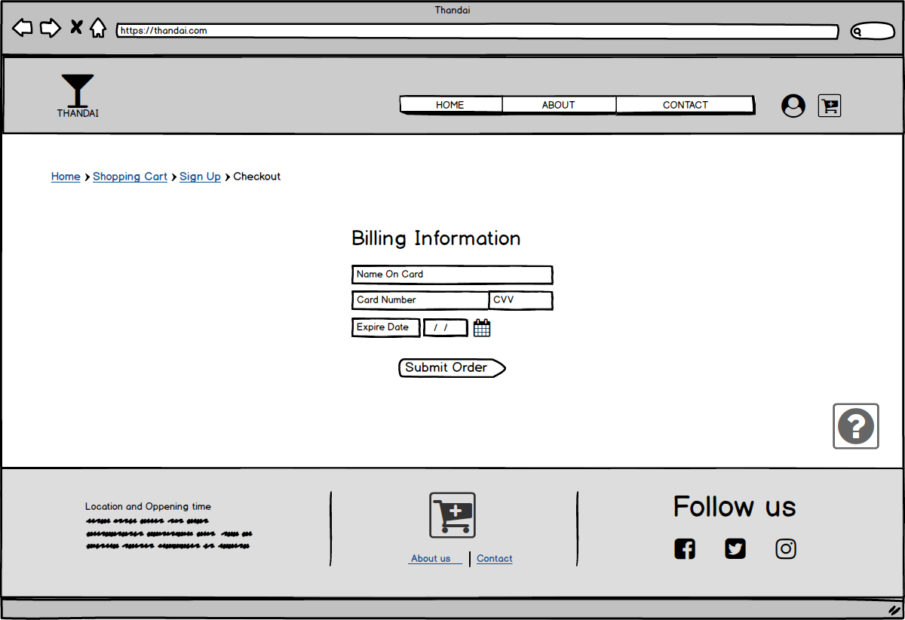CheckOut

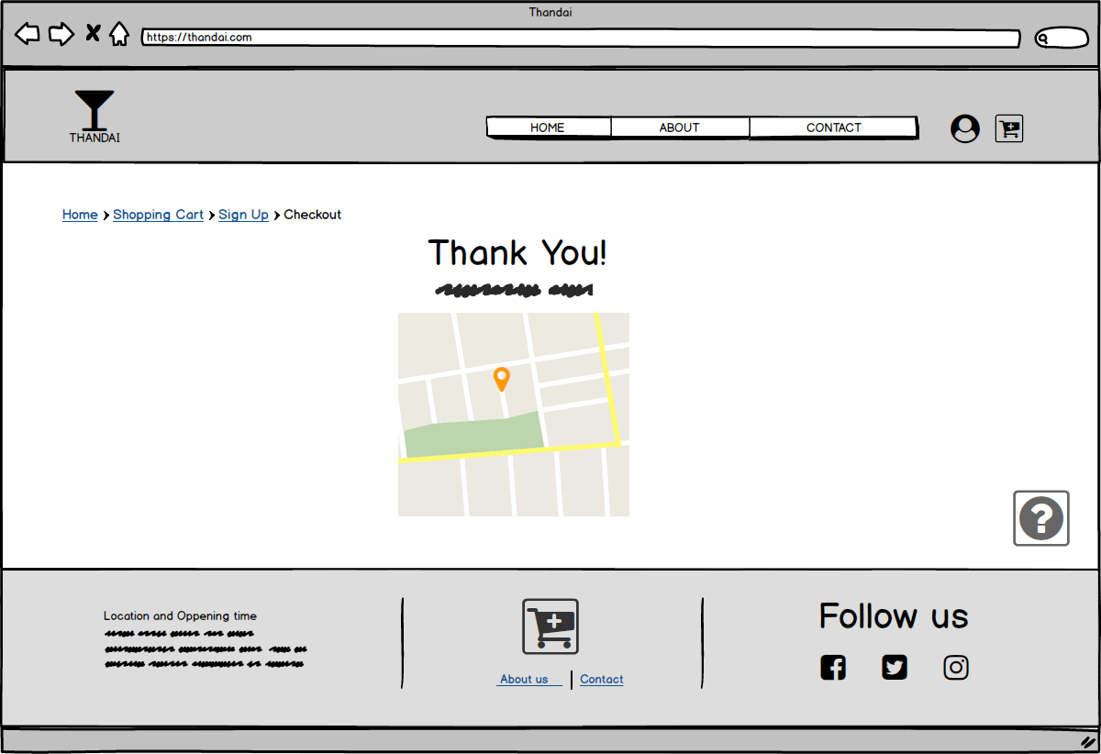Track Order

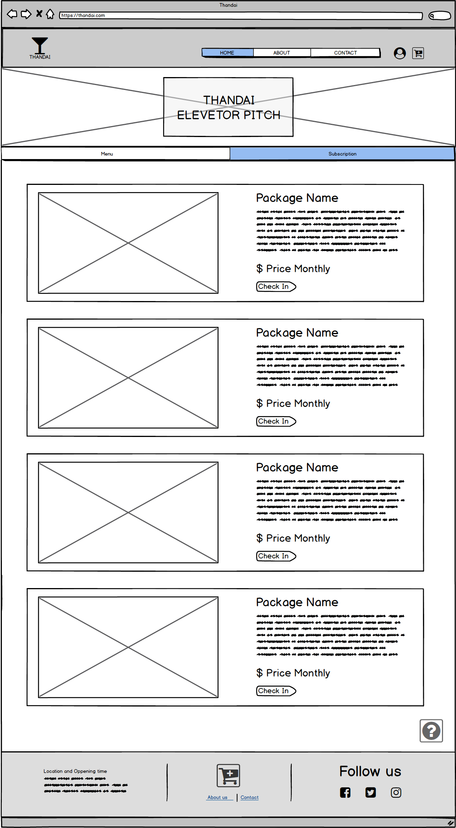Desktop Home

Daily Juice Delivery

Subscription

Sign Up

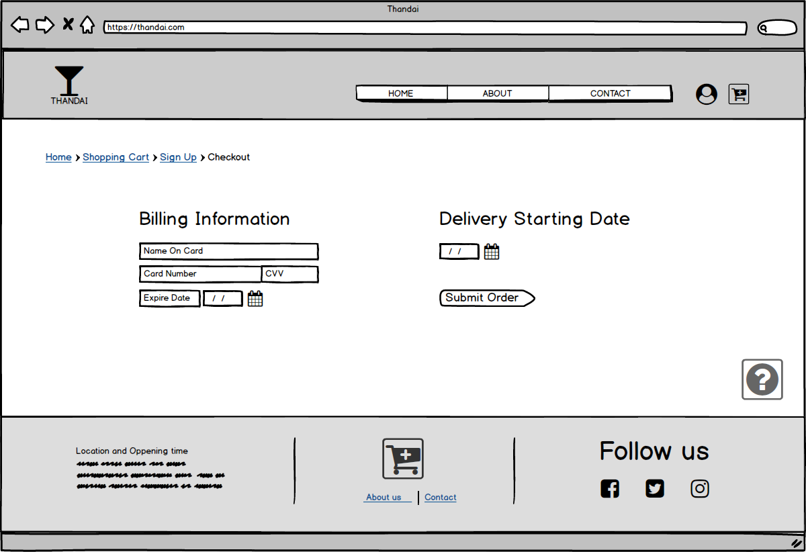Subscription Checkout

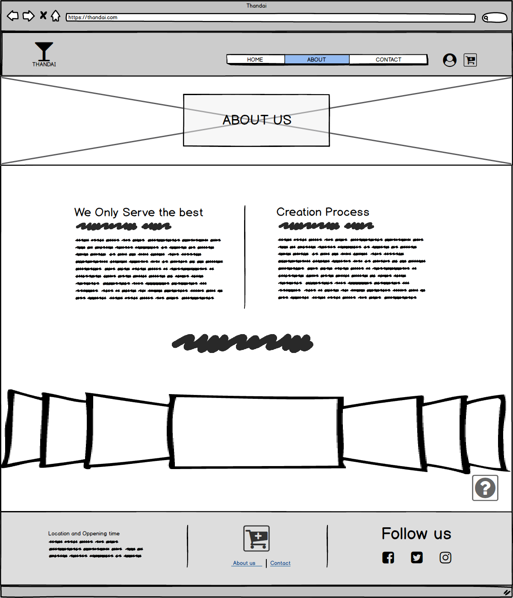About

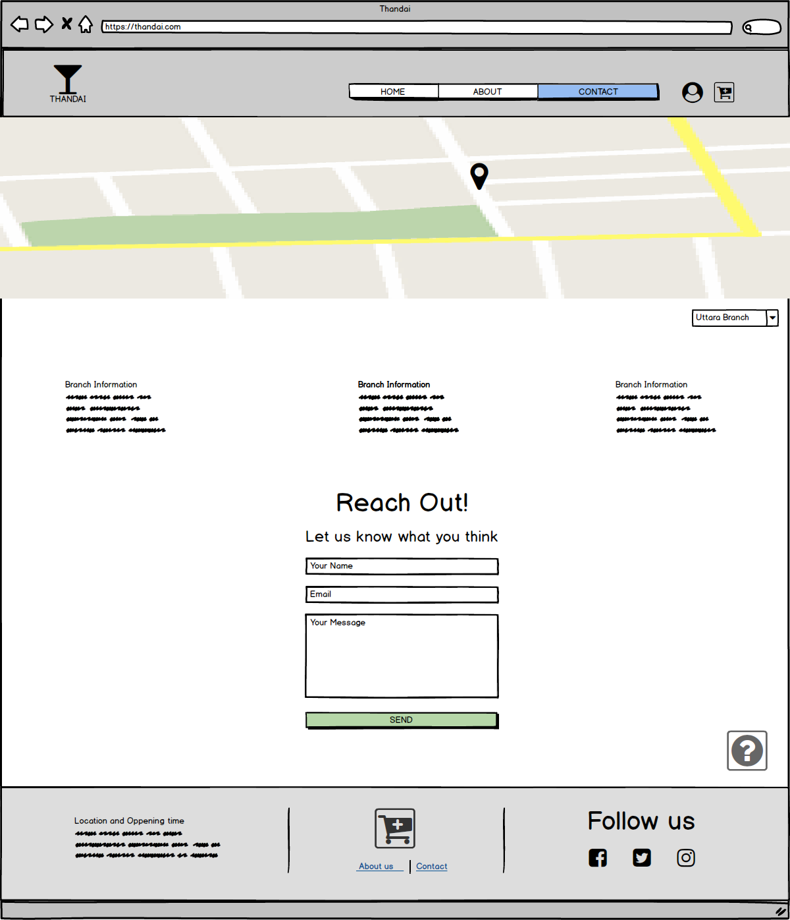Contact Us

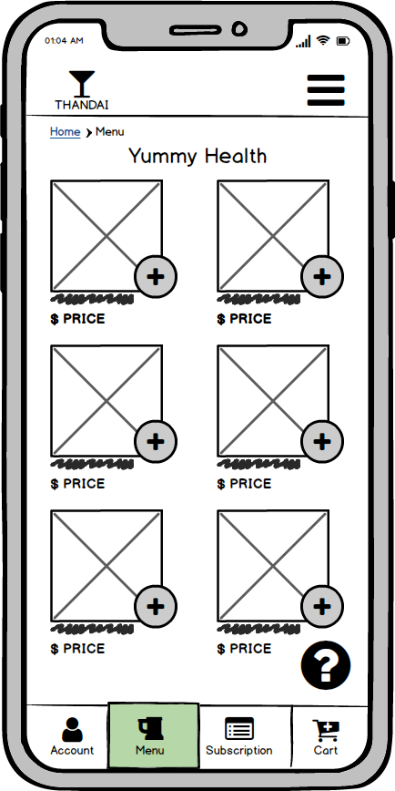Mobile Home